08/06/2020
Customer Name
Address
Dear Customer Name，

Re: F17 Formply Increase 10% May 1st, 2020
These price increasing are being driven by a number of factors including strong global financial pressure due to the COVID-19 virus, and the severe declining value of the Australian dollar against the USD. These factors, coupled with the level of buoyancy of activity in the construction market, continue to drive prices in an upward trend.
Victoria Scaffolding to date has been able to absorb the majority of these increases but the further upward movements in steel prices means that we have no choices but to pass these new increases on.
Victoria Scaffolding understands that the impact rising prices have on your business as we do on our own. We can assure you that we are, and will continue to, put an enormous amount of effort into doing whatever we can to mitigate the need to increase prices.
We continue to work vigorously on improving the quality of our products, systems, services and overall offer to ensure we are the supplier you expect us to be.
We sincerely appreciate your continued loyalty and support and should you have any concerns, please feel free to contact us directly for clarification regarding this matter.
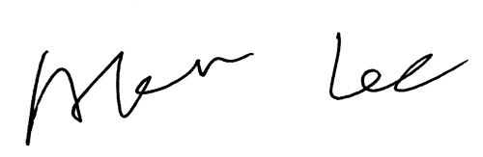
Best regards,

Akira Lee
General Manager Sales & Marketing
Victoria Scaffolding Pty Ltd

